ee

Cinemática de robots

Parámetros DH

Juan Ramirez Arenas 8°B Ing. Mecatrónica

Prof.: Moran Garabito Carlos Enrique

**Parámetros DH**

**Calculo de matrices homogéneas**

**Robot # 1.**

|  |  |  |  |  |
| --- | --- | --- | --- | --- |
| **i** | **ai-1** | **Ζi-1** | **di** | **θi** |
| **1** | **0** | **-90** | **0** | **Θ1** |
| **2** | **L1** | **0** | **0** | **Θ2** |
| **3** | **L2** | **0** | **0** | **Θ3** |

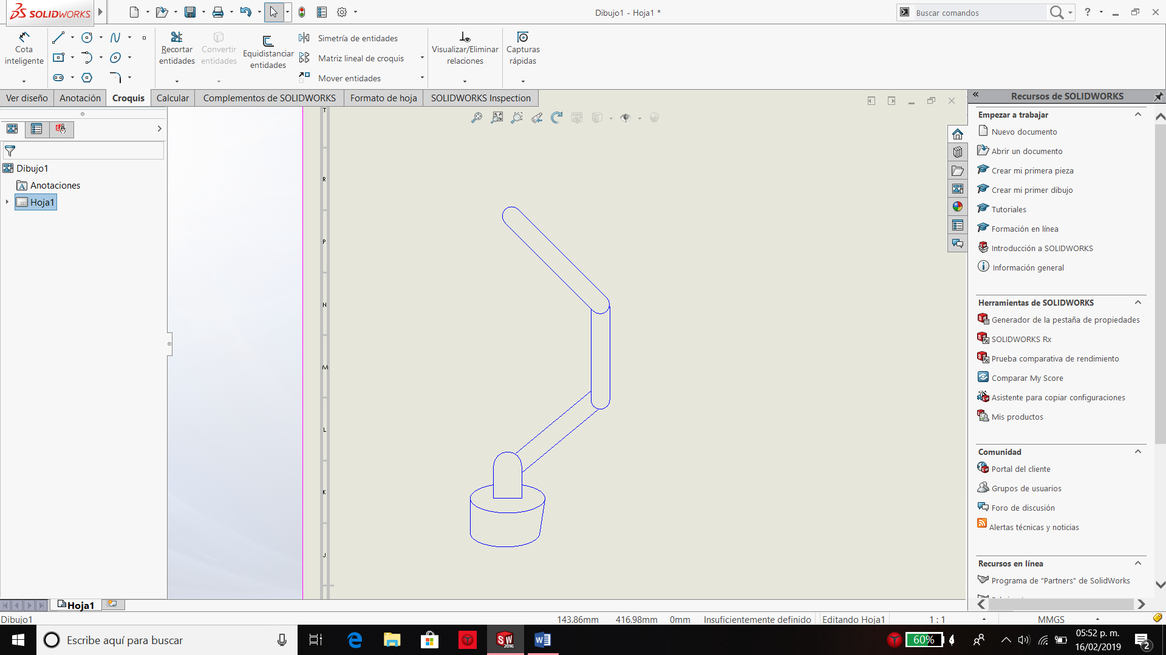

=[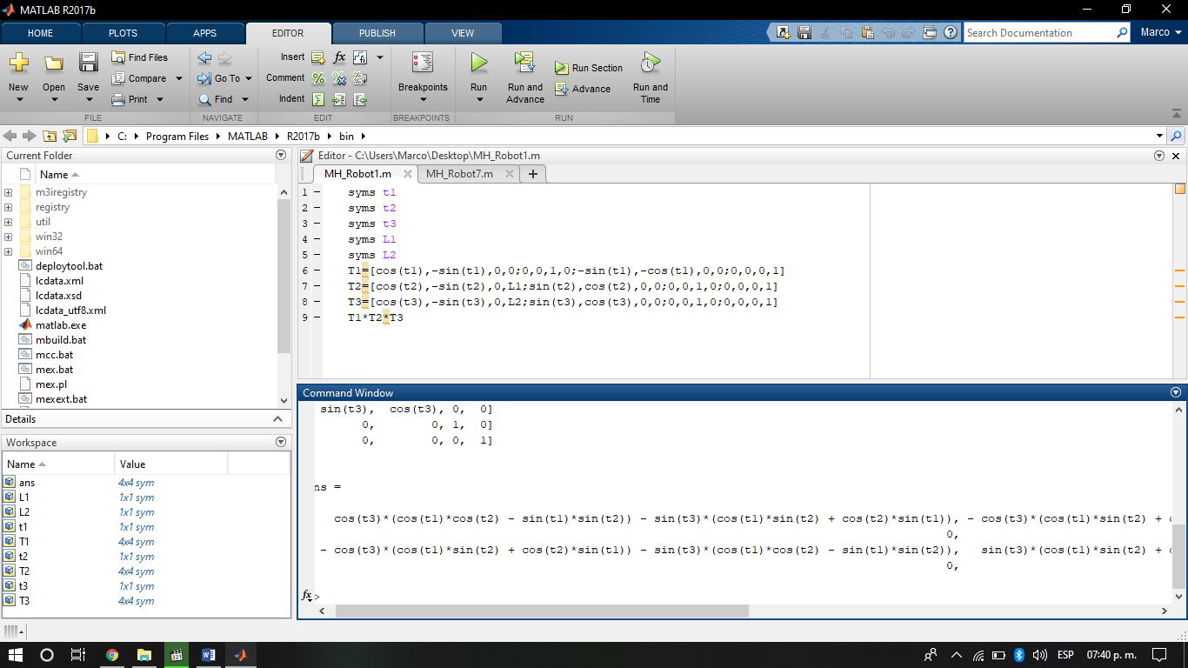

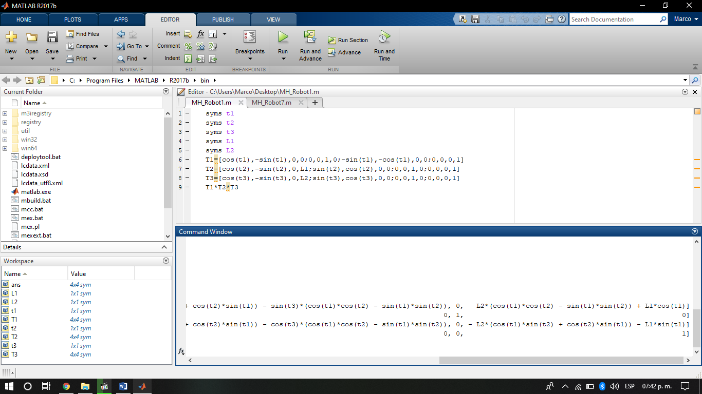]

**Robot 2**

|  |  |  |  |  |
| --- | --- | --- | --- | --- |
| **i** | **ai-1** | **Ζi-1** | **di** | **θi** |
| **1** | **0** | **0** | **0** | **Θ1** |
| **2** | **L1** | **-90** | **0** | **Θ2** |
| **3** | **L2** | **0** | **0** | **Θ3** |

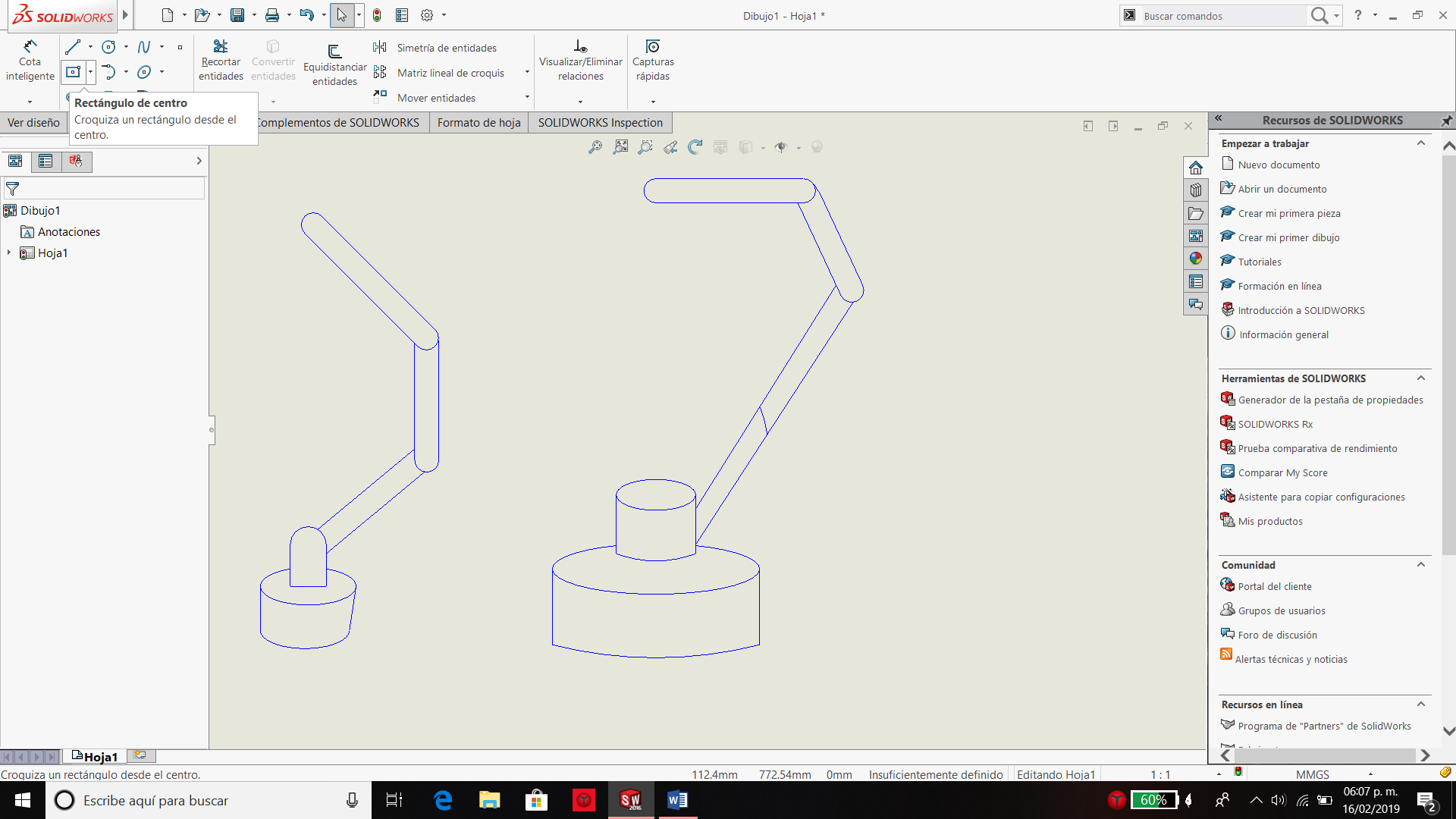

= [

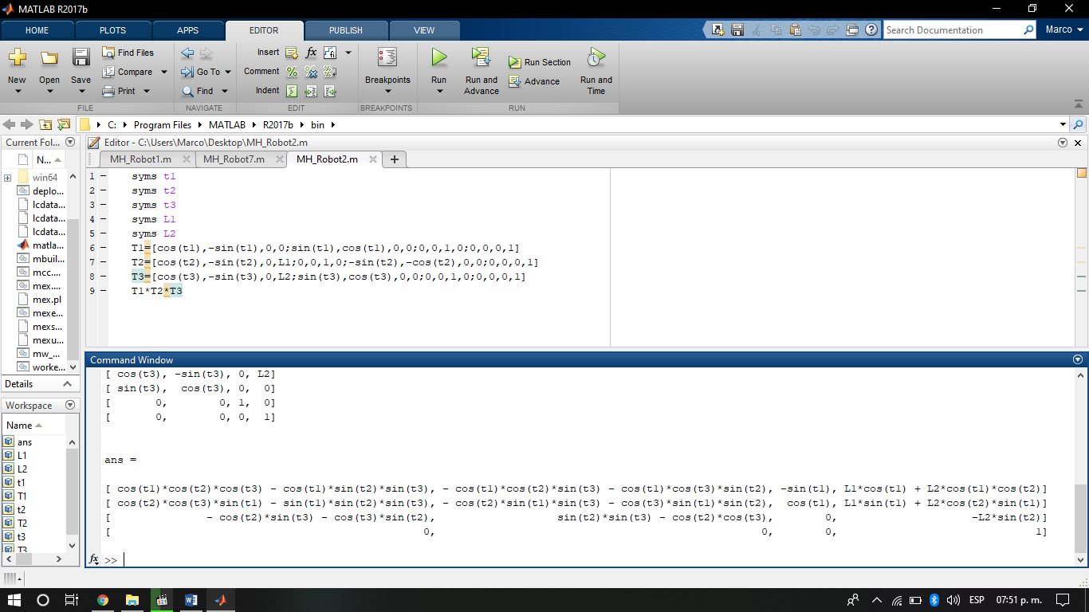]

**Robot 3**

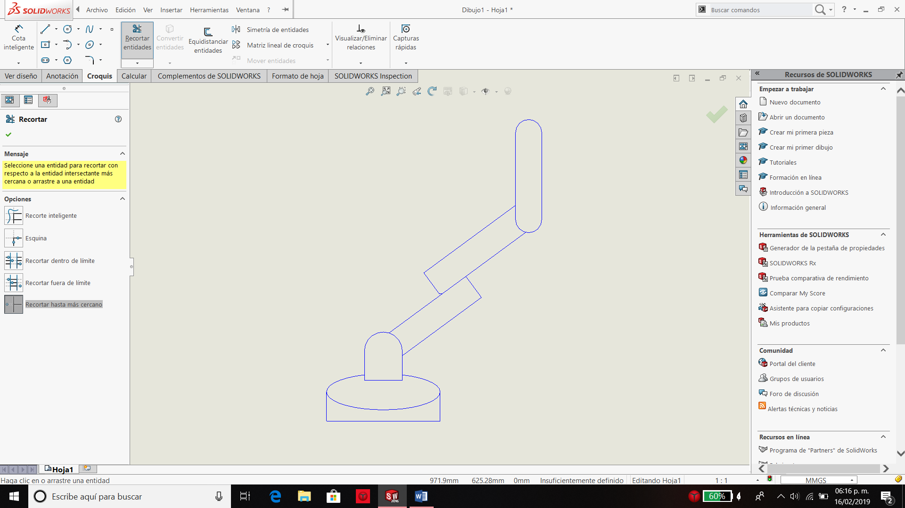

|  |  |  |  |  |
| --- | --- | --- | --- | --- |
| **i** | **ai-1** | **Ζi-1** | **di** | **θi** |
| **1** | **0** | **-90** | **0** | **Θ1** |
| **2** | **L1** | **90** | **d2** | **Θ2** |
| **3** | **L2** | **-90** | **0** | **Θ3** |

=[

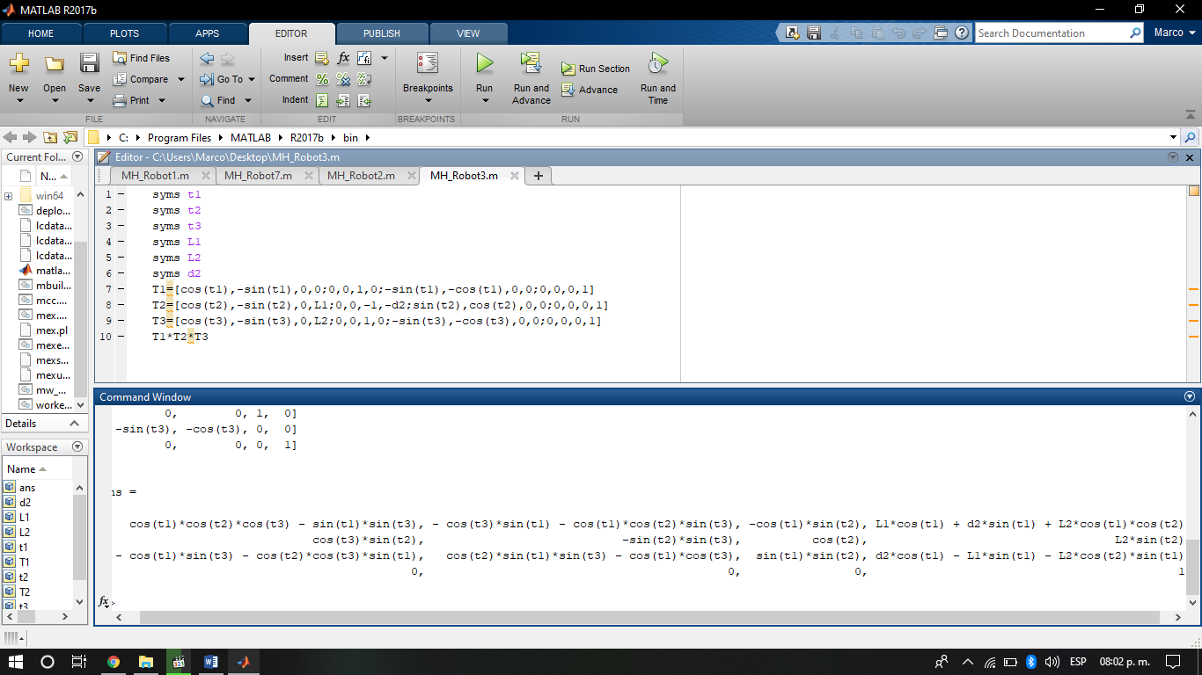]

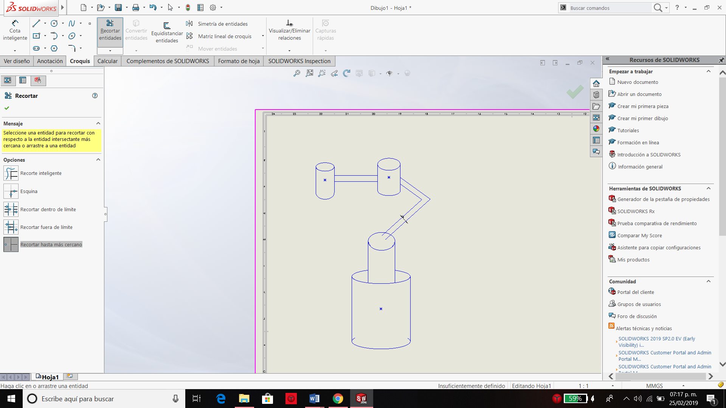**Robot 4**

|  |  |  |  |  |
| --- | --- | --- | --- | --- |
| **i** | **ai-1** | **Ζi-1** | **di** | **θi** |
| **1** | **0** | **0** | **0** | **Θ1** |
| **2** | **3/4L** | **0** | **0** | **0** |
| **3** | **L** | **0** | **d3** | **0** |

=[



